Advertising Rates

Education In Black & White

Specifications:

11 X 15 newspaper
10,000 copies
Full color
Distributed to schools, libraries, & community locations

Rates:

Full Page – 10 1/4” X 14” ------------ $1500
Half Page – 10 1/4” X 7” ------------- $ 800
Quarter Page – 5” X 7”-------------- $ 500
Quarter Page – 3 1/2” X 10 1/4”--- $ 500
Eighth Page – 5” X 3 1/2” ----------$ 275
Business Card – 1 3/4” X 3 3/8”--- $ 100

Name;
Organization:
Address:
City/State/Zip
Phone:
Email:
Size Ad: Payment:
Contribution:

Please attach photo ready ad or copy (with photo or logo) for the ad and we will create it
Please make checks payable to Moonstone Arts Center
Email this form to larry@moonstoneartscenter.org and then send payment to
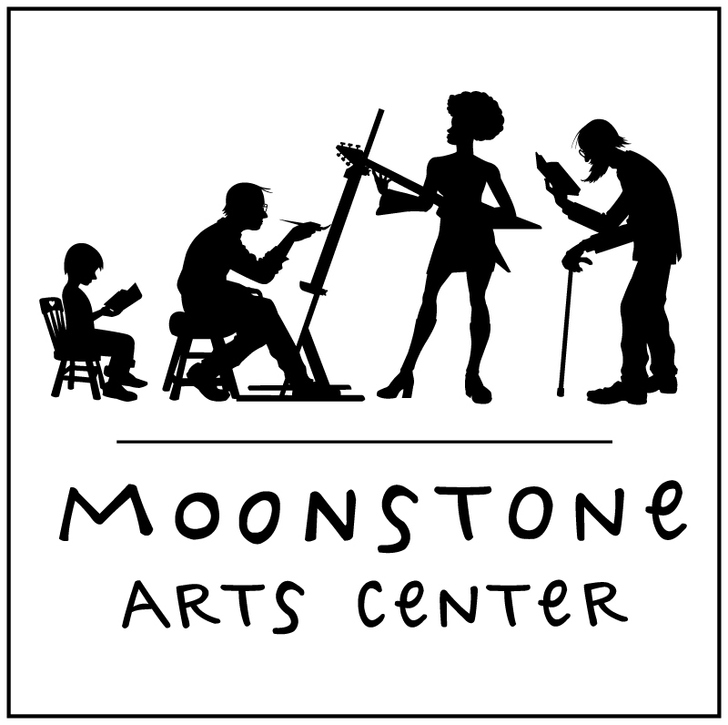
Moonstone Arts Center
110A S. 13th Street, Philadelphia PA 19107, 215-735-9600
www.moonstoneartscenter.orglarry@moonstoneartscenter.org

If you would like to see a previous newspaper in this series please contact us

