Moonstone @ Toast Cafe
1201 Spruce Street - Philadelphia
Moonstone Gold
Thursday April 13, 2016 – 6:30pm
Samuel R. Delany
Tribute, Interview & Reading
Samuel Ray Delany, Jr., Chip Delany to his friends, is an American author, professor and literary critic. His work includes fiction, memoir, criticism, and essays on sexuality and society. His science fiction novels include Babel-17, The Einstein Intersection (winners of the Nebula Award for 1966 and 1967 respectively), Nova, Dhalgren, and the Return to Nevèrÿon series. After winning four Nebula awards and two Hugo awards over the course of his career, Delany was inducted by the Science Fiction and Fantasy Hall of Fame in 2002. In 2010 he won the third J. Lloyd Eaton Lifetime Achievement Award in Science Fiction from the academic Eaton Science Fiction Conference at UCR libraries. The Science Fiction Writers of America named him its 30th SFWA Grand Master in 2013.
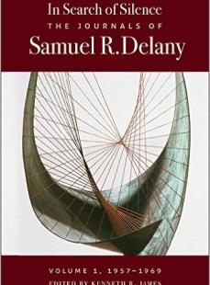
In Search of Silence: The Journals of Samuel R. Delany, Volume 1, 1957-1969 ($40.00 Wesleyan, Jan 13, 2017) - For fifty years Samuel Delany has cultivated a special relationship with language in works of fiction, criticism, and memoir that have garnered critical praise and legions of fans. The present volume – the first in a series – reveals a new dimension of his genius. In Search of Silence presents over a decade’s worth of Delany’s private journals, commencing in 1957 when he was still a student at the Bronx High School of Science, and ending in 1969 when he was living in San Francisco and on the verge of reconceiving the novel that would become Dhalgren.
Interviewed by Don Riggs – “I am currently writing a series of entries for an Encyclopedia of Literary and Cinematic Monsters; my entries are on Tolkien’s Monsters, Fauns and Satyrs, the Sphinx, and Gargantua and Pantagruel. I have recently written an entry on Philip K. Dick’s A Scanner Darkly and Richard Linklater’s film version of that novel by the same title. Much of my scholarly work deals with the Fantastic in the arts, both science fiction and fantasy, in literature and in film. I have recently published poems online in Orizon Literar (Bucharest) and write a regular column on poetry for the online journal Press 1.”
A Tribute to Samuel R. Delany – a chapbook of praise and praise poems from Chip’s many admirers for his 75th birthday (April 1, 2017). ($10.00, Moonstone Press)

Books will be available for purchase and to be autographed

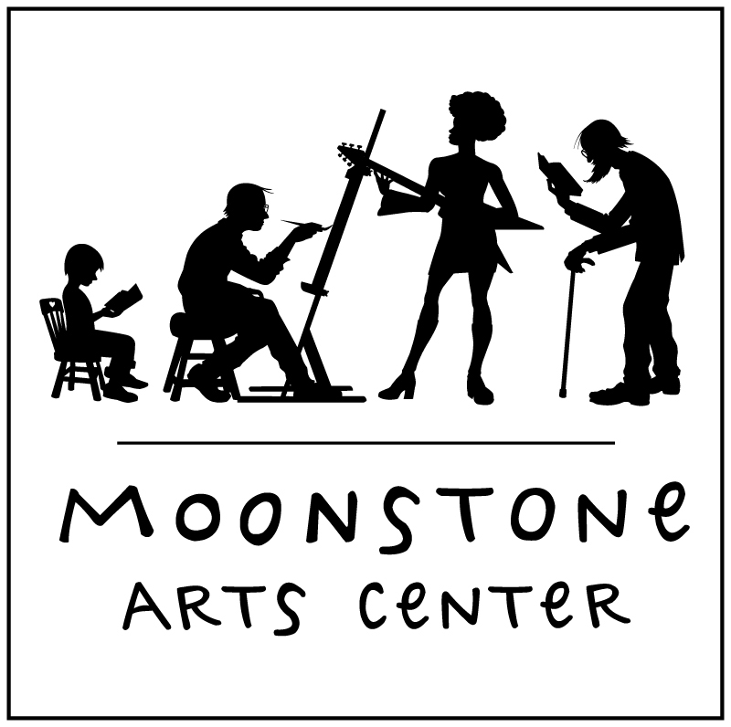
Moonstone Arts Center Office
110A S. 13th Street, Philadelphia
215-735-9600, www,moonstoneartscenter.org

like us/friend us on facebook

